Write a program in C to demonstrate how to handle the pointers in the program.

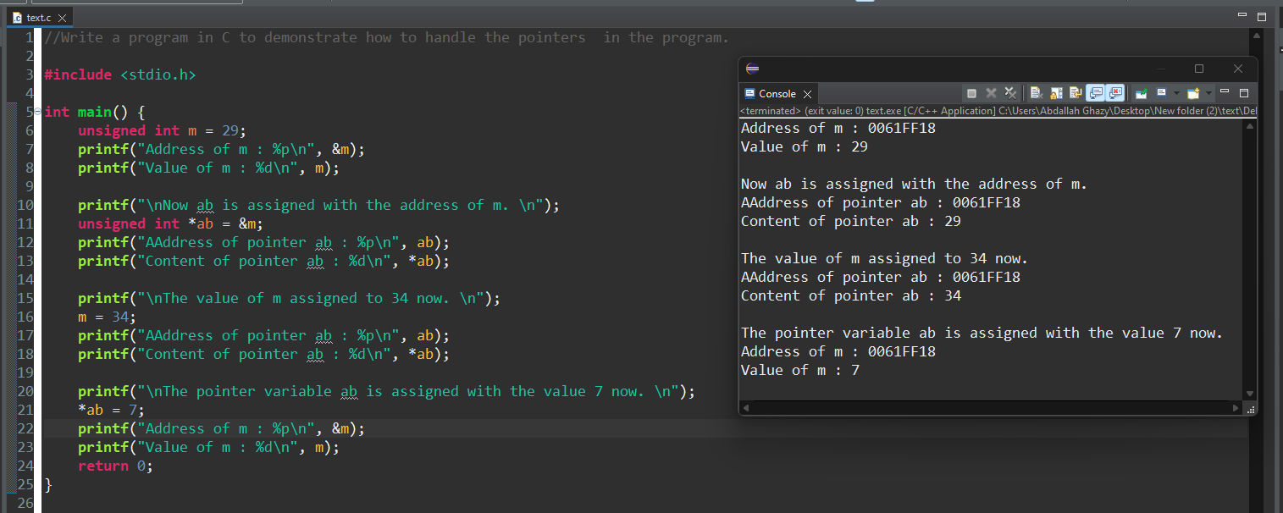

Write a program in C to print all the alphabets using a pointer. Go to the editor

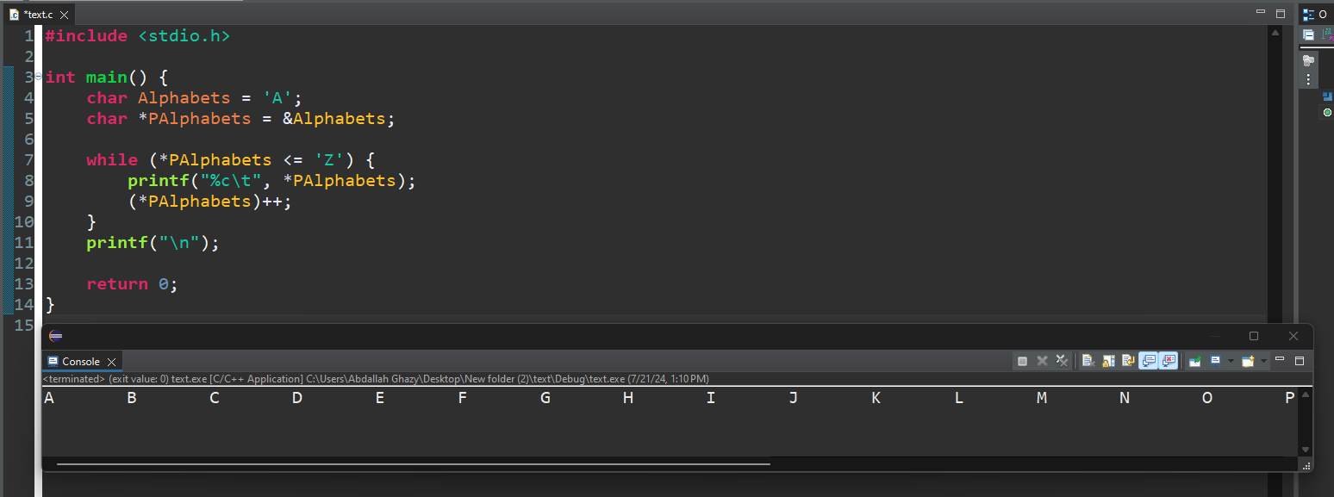

Write a program in C to print a string in reverse using a pointer

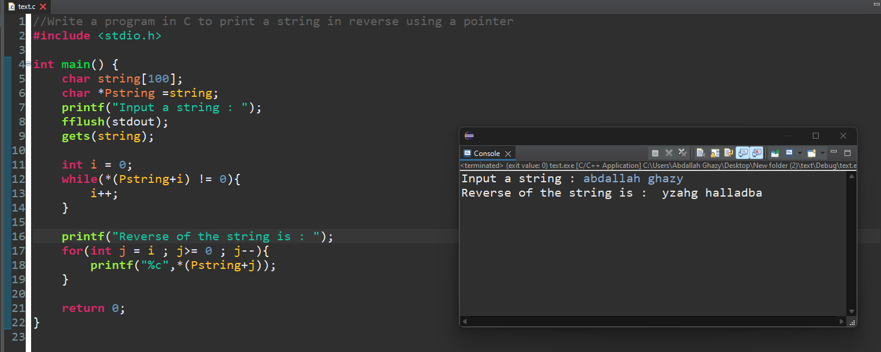

Write a program in C to print the elements of an array in reverse order. Test Data :

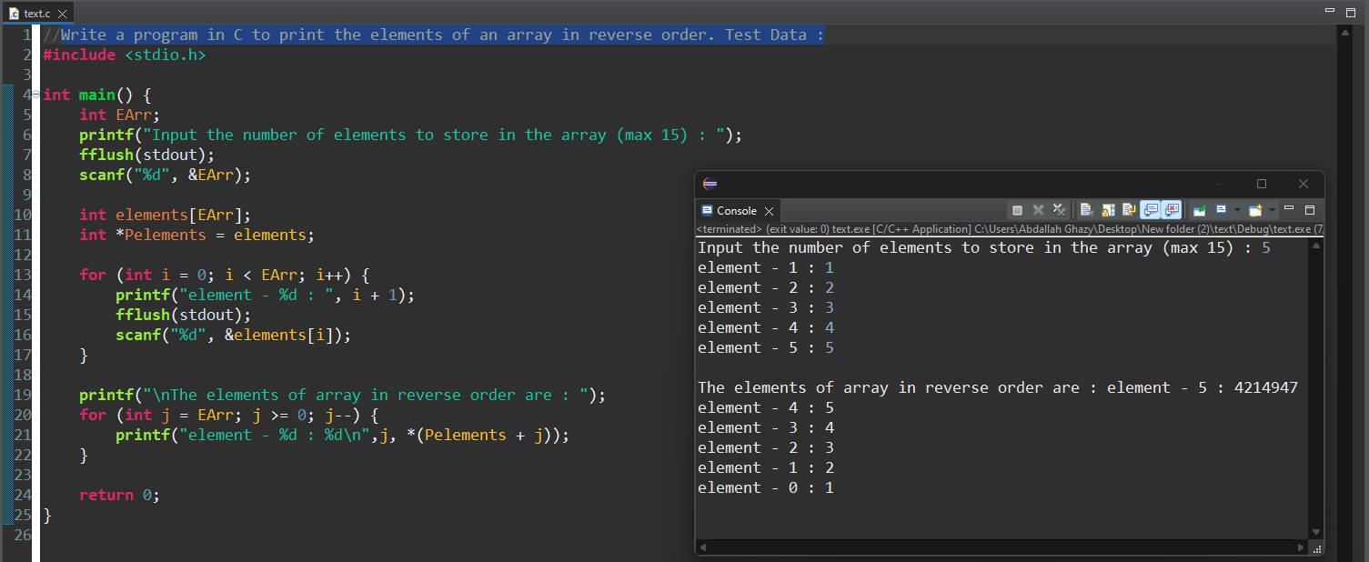

Write a program in C to show a pointer to an array which contents are pointer to structure.

